________________

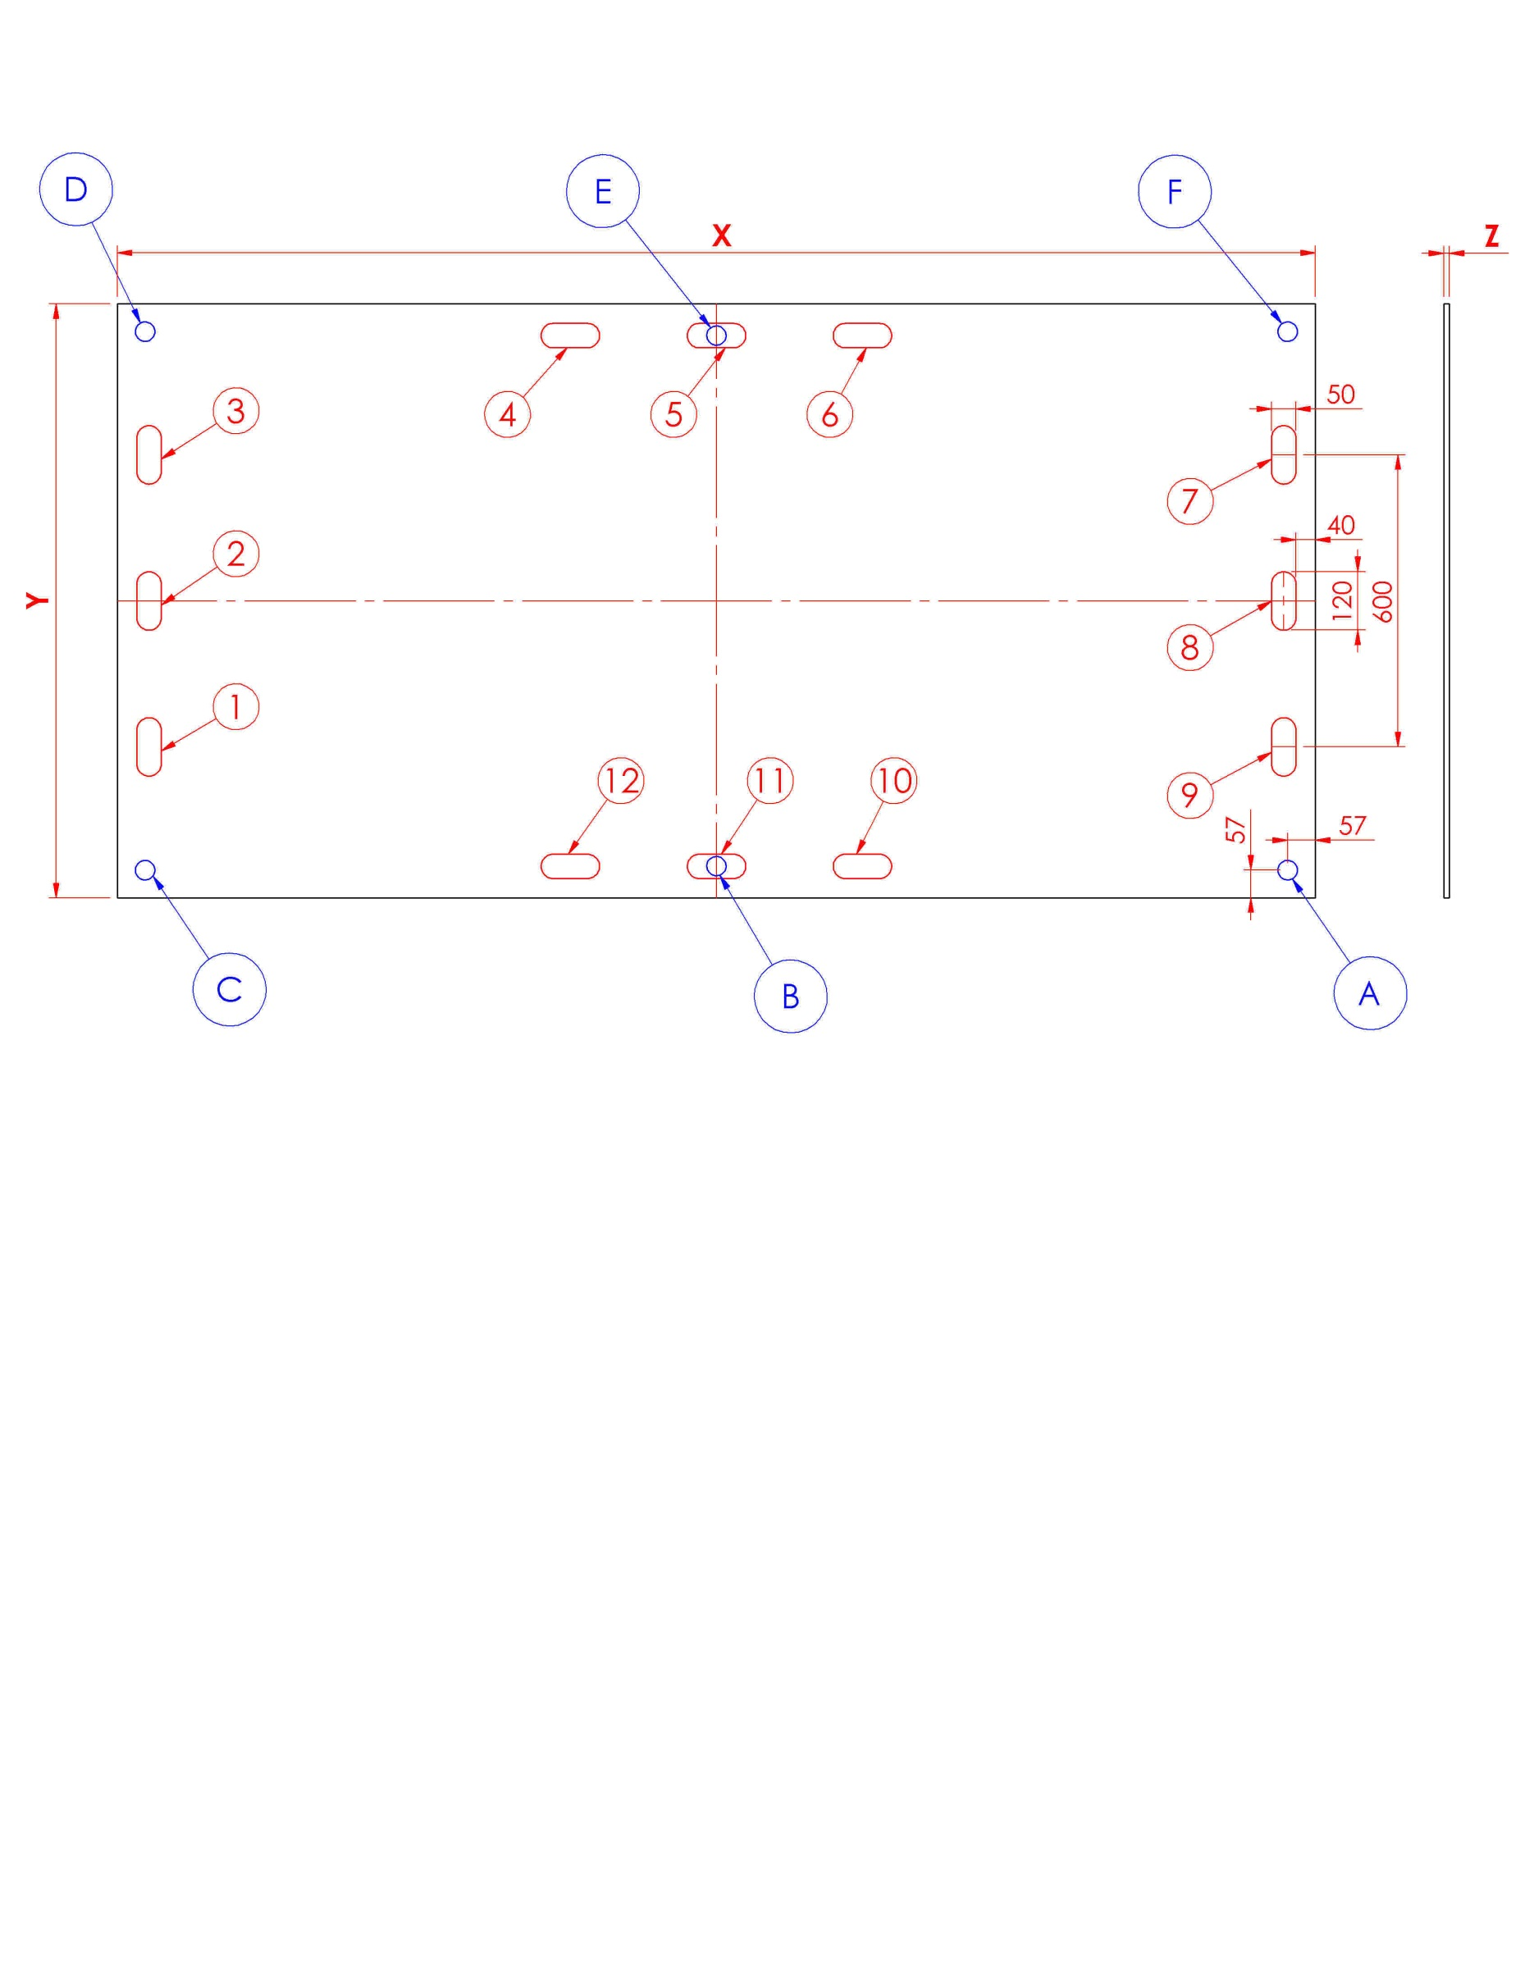
Comment/Bemerkungen:
Amount total/Anzahl :
___________ pcs.
Amount/Anzahl pr. palle/pro Palette
___________ pcs.

MEASUREMENTS:
X | Mm
Y | Mm
Z | Mm
Fastening hole positions.
A
B
C
D
E
F
Select your desired size of fastening holes in the board.
Ø25
Ø30
Ø40
Custom

Logo :______________
Handle distance: Select position (X)
STRUCTURE
PLAIN
Board Color:
DATE: ______________ ORDER: __________________________
Delivery of plates :
Date :
Receiver :
Plates returned :
Date : ______________

Handles measure: 50mm x 120mm. Select position (X)
1
2
3
4
5
6
7
8
9
10
11
12

